Texthelp Ltd.
BrowseAloud Plus Overview
BrowseAloud Plus version 1.3

Donna Thomson, BrowseAloud Marketing Manager
January 2014
BrowseAloud Plus Overview

Thank you for your interest in BrowseAloud Plus.

Please find below information on BrowseAloud Plus.

If you have any questions regarding any of the information contained, please do not hesitate to contact me.

I look forward to hearing from you.

Yours sincerely,

Gian Wild
Accessibility Specialist
BrowseAloud Reseller
Tel: 02 6108 3689
Email: gian@accessibilityoz.com.au
Web: www.accessibilityoz.com.au

BrowseAloud Plus Overview
Table of Contents

About BrowseAloud Plus 2
BrowseAloud Plus Toolbar Functionality 5
Play by ‘Hover Highlighting’ 5
Play by ‘Text Selection’ 5
NEW Translator 6
MP3 Maker 7
Text Magnification 7
NEW Screen Mask 7
NEW Simplifier 8
NEW User Settings 10
What’s New 11
Continued Functionality 12
Recommended Browsers & Platforms 12
Customer Testimonials 13
BrowseAloud Plus Support 14
About Texthelp 15

About BrowseAloud Plus
BrowseAloud Plus adds high quality speech and reading support tools to online content to extend the reach of websites for the 46% of the population that requires reading support. This includes those with:

- Dyslexia
- Literacy Difficulties
- English as a Second Language (ESL)
- Mild Visual Impairments

Website visitors browsing the web from their Smartphone, Tablet, PC or Mac can utilise BrowseAloud Plus and benefit from the reading support that suits their individual needs and preferences, whether they are ‘At Home, In the Office or On the Go’.

Key Benefits to Website Owners

- Reach a Wider Audience
- Reduce Costs
- Help Compliance with Legal Obligations
- Reduce Barriers on the Web
- Improve Access to Information on your Website for 46% of the Population
- Demonstrate Commitment to Corporate Social Responsibility

Key User Benefits
- Zero Implementation and Zero Download
- Compatibility with all Major Browsers and Devices
- High Quality Voices and International Languages
- Secure Web Page and PDF Reading
- Automatic Updates, and
- Free to the End User

What it Reads

- All Accessible Content
- ALT Tags Behind Pictures
- Accessible Flash and JavaScript
- Online PDF Documents
- Secure HTTPS Web Pages
- Online Form Fields
- Intranets and Extranets
- Social Media Pages (such as Twitter)
- Search Results Pages (such as Google)
About BrowseAloud Plus

BrowseAloud Plus reads website content out loud in a high quality, human-sounding voice.

Each word is highlighted as it is read aloud and the sentence is highlighted in a contrasting colour. This allows users to easily identify what text is being read aloud and navigate within and between web pages. BrowseAloud Plus is free to website visitors, there’s no download and it is really easy to get.


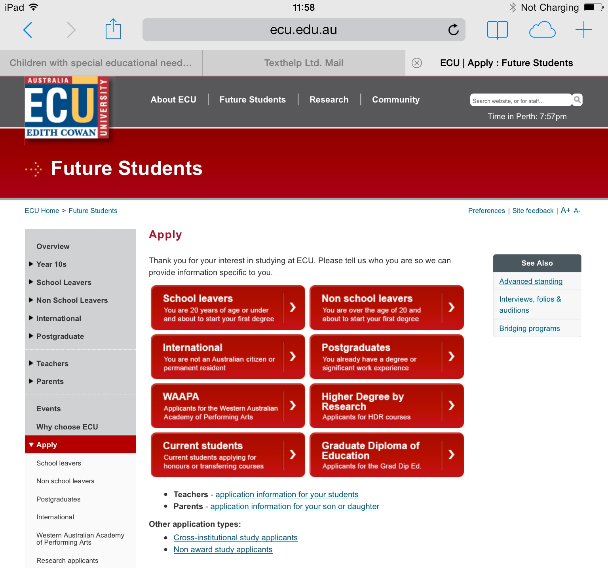

BrowseAloud Plus Toolbar Functionality


BrowseAloud Plus delivers high quality speech to assist those with dyslexia, literacy difficulties, mild visual impairments and where English is a second language when browsing the web. BrowseAloud Plus features and options are accessed from an easy to use, floating toolbar. They include:

- Play by ‘Hover Highlighting’
- Play by ‘Text Selection’
- NEW Translator
- MP3 Maker
- Text Magnification
- IMPROVED Screen Mask
- NEW Simplifier
- NEW User Settings



Play by ‘Hover Highlighting’
To start speech, move your mouse pointer over the text (and click or tap the text if you are using a mobile or tablet device). BrowseAloud Plus uses dual-colour highlighting which highlights the block of text in one colour and the spoken word in another to give a clear indication of what text is being read aloud and to aid navigation. The audio-visual reinforcement also improves word recognition and comprehension.



Play by ‘Text Selection’
As an alternative to Hover Highlighting, users can select specific text to hear it read aloud. Again, the text will be read out using synchronous dual-colour highlighting.



NEW Translator

Translate web pages and PDF documents into 74 languages! Speak the translated text where there is a matching voice available; currently 33 of the supported languages. Web owners can choose to have the translator switched on/off or choose to have individual languages switched on/off as desired.

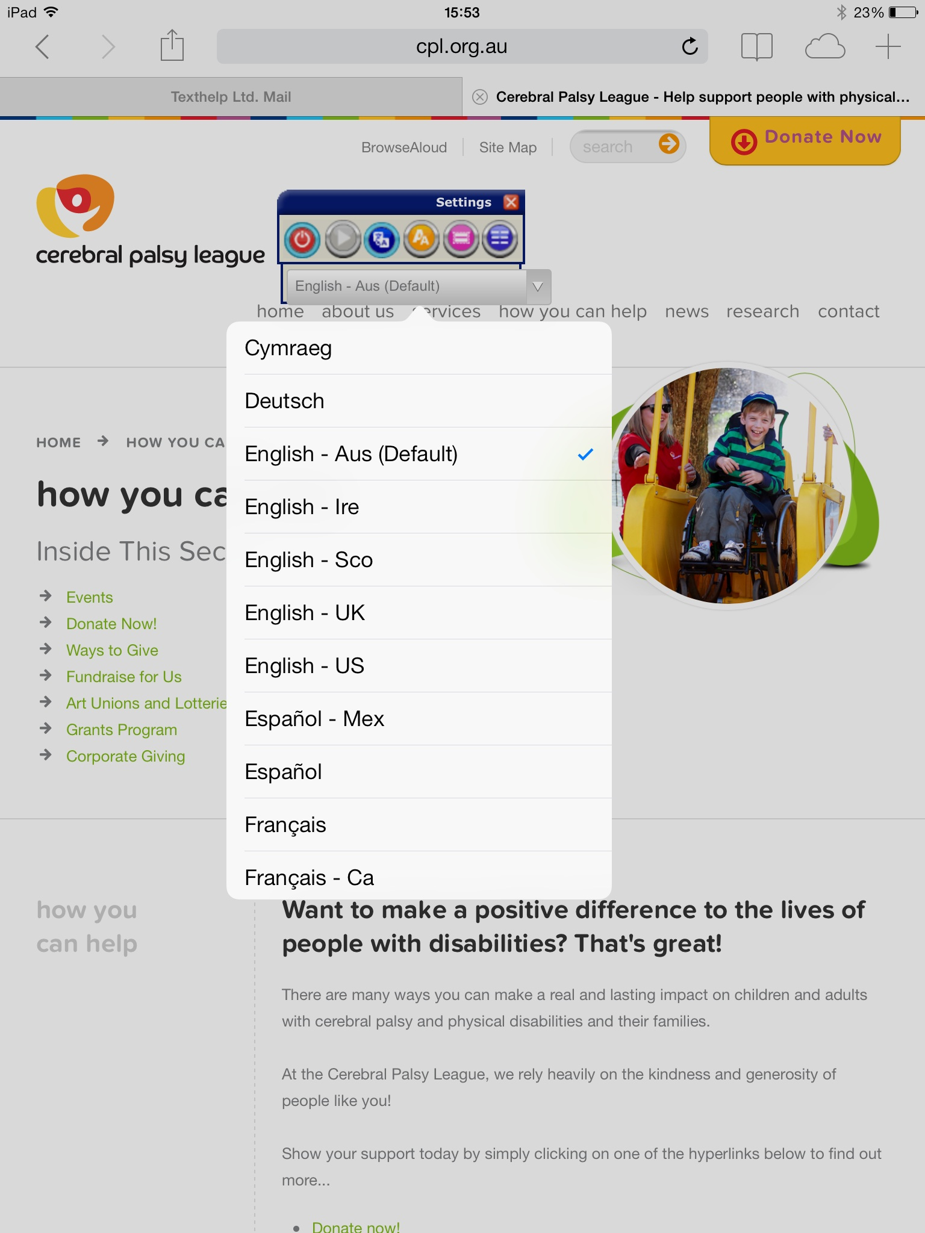
Translate web pages into any of the 74 languages provided by selecting the language from this drop down menu.

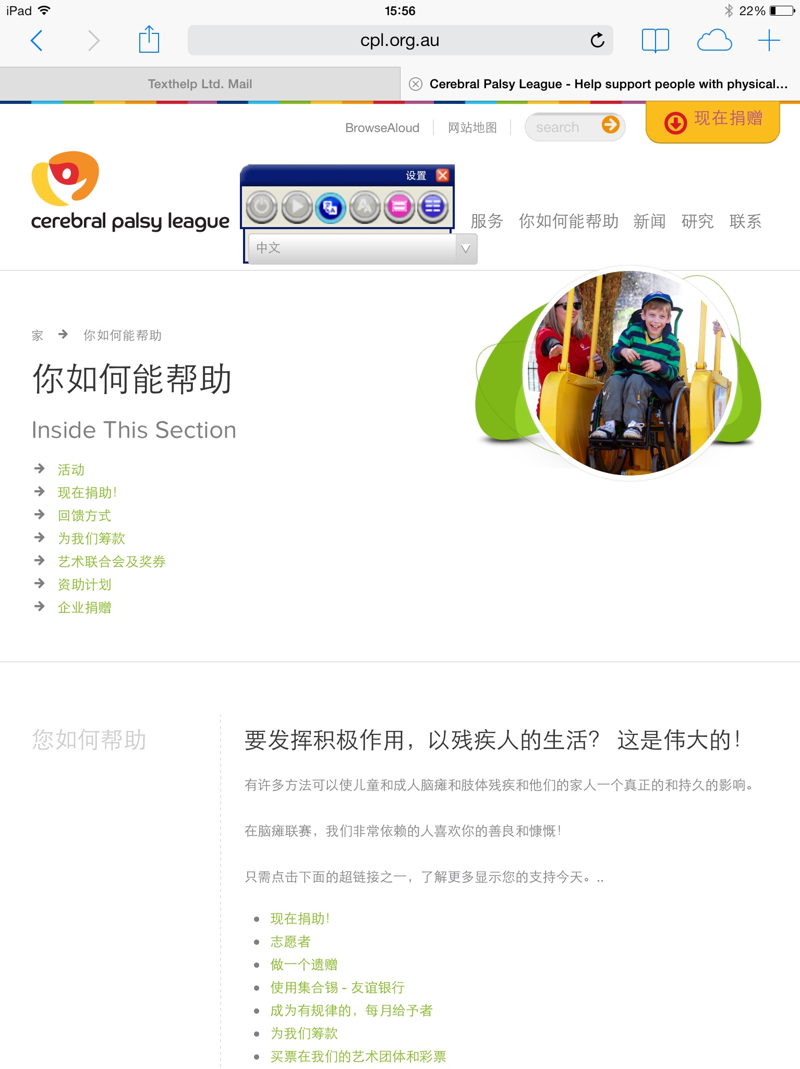



MP3 Maker

Convert text to an MP3 file with our MP3 Maker. The text can then be saved and listened to at a later time, at home or on the move. Web Owners can create MP3 files to be hosted and streamed directly from their website.


Text Magnification
BrowseAloud Plus can magnify the text as it is read aloud. The magnified text is displayed with synchronous highlighting in a single line at the top of the screen as the text is being read aloud.



NEW Screen Mask
Block distractions on your screen with our Screen Mask. A semi-opaque black mask extends across your screen leaving a letterbox reading window clear. This helps you to focus on the section of the web page you are most interested in.
Now available on touch screen devices. The Screen Mask will move up/down in response to clicking on the clearly defined large buttons on the right hand of the screen.
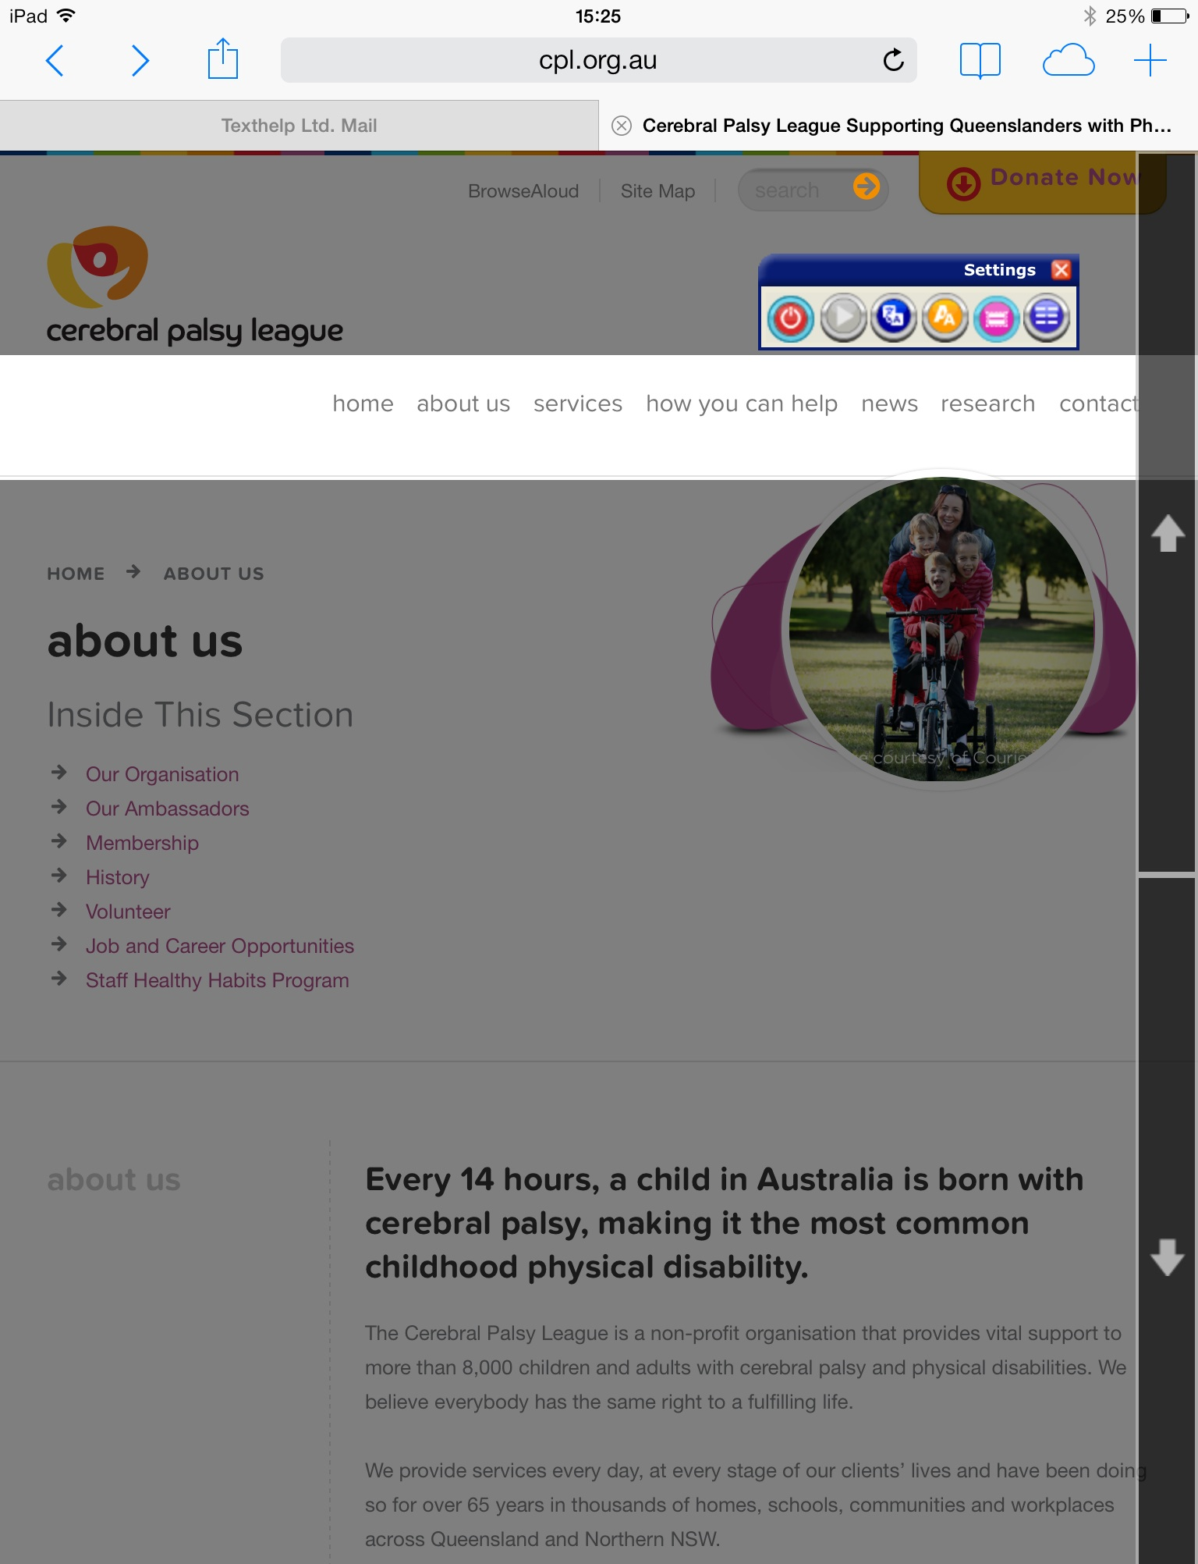
On Touch Screen Devices, the Screen Mask will move up/down in response to clicking on the clearly defined large buttons.



NEW Simplifier

Remove clutter from your screen with our new Simplifier. The feature presents the current web page in a more user-friendly layout that is free from the secondary information on the page. Once simplified, the text can be summarised¹, translated and printed to further help users to digest the information on the page.

Users can customise this feature to suit their individual preferences, such as: increase/decrease font size, change the colours used to highlight text and set the level of summarisation.

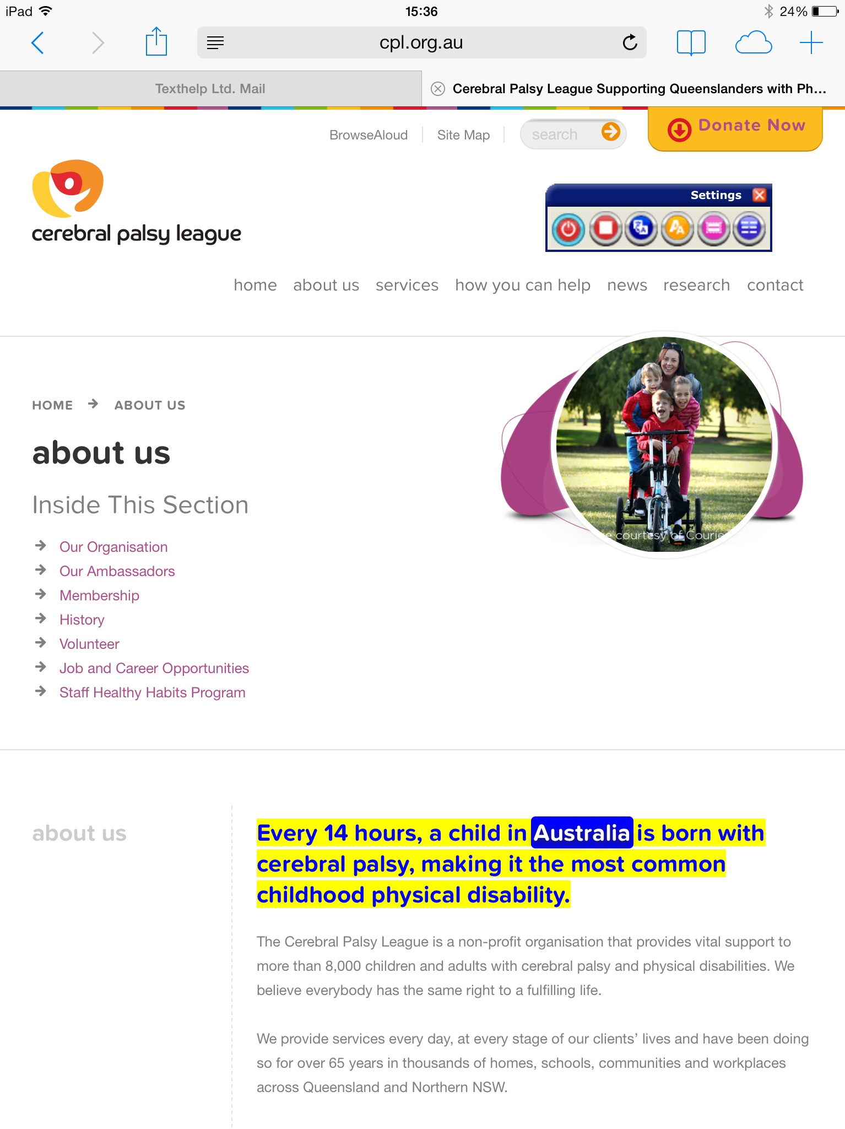

Customise how this page is viewed to suit individual user preferences.

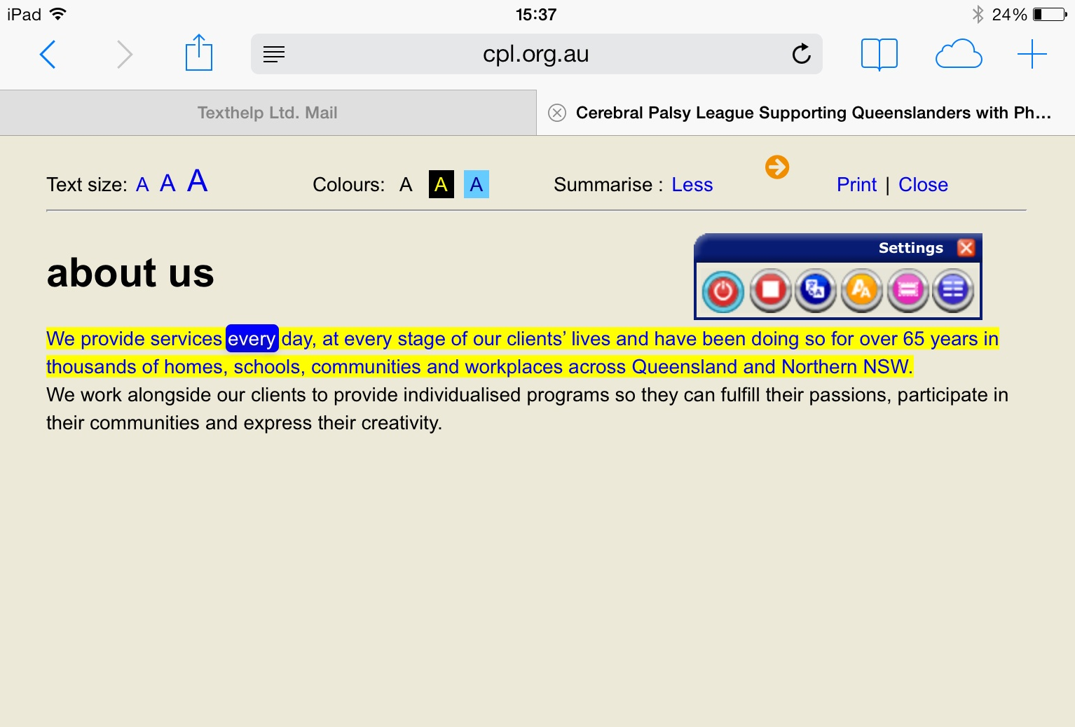

¹ Summarisation currently available in English language only and currently does not extend to PDF documents.

NEW User Settings
Users can customise BrowseAloud Plus to suit individual needs with options to alter the voice speed, highlighting colours and size of text during magnification. Users can also select which functions should be switched on/off by default, such as the hover highlighting, text magnification and the simplifier.

These individual settings can be stored by simply creating a user account with BrowseAloud, with a name and email address, and retrieved by logging in before each browsing session.

Users can customise BrowseAloud Plus settings to suit individual needs or preferences.

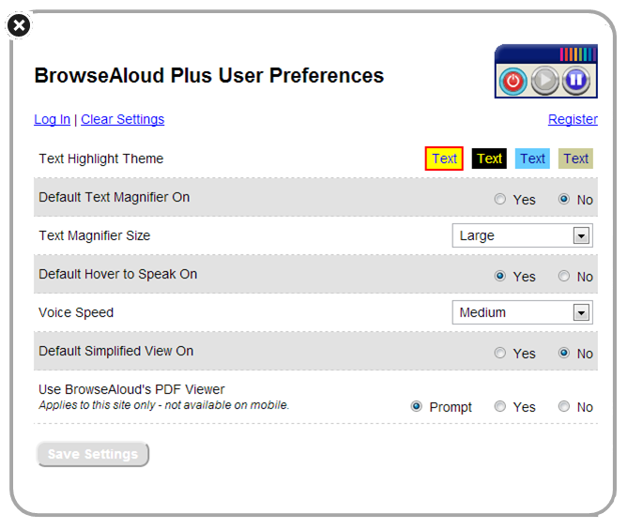

What’s New
A new version of BrowseAloud Plus was released on January 17, 2014. We are thrilled to announce that it now includes:

Translator
Translate web pages and PDF documents into 74 languages! Speak the translated text where there is a matching voice available; currently 33 of the supported languages. Web owners can choose to have the translator switched on/off or choose to have individual languages switched on/off as desired.

Simplifier

Removes clutter from the user’s screen. This feature presents the current web page in a more user-friendly layout that is free from the secondary information on the page. Once simplified, the text can also be summarised², translated and printed to further help users to digest the information on the page.

User Settings

Users can customise BrowseAloud Plus to suit individual needs with options to alter the voice speed, highlighting colours and size of text during magnification. Users can also select which functions should be switched on/off by default, such as the hover highlighting, text magnification and the simplifier.

Improved Screen Mask
The Screen Mask feature is now available on touch screen devices! The Screen Mask will move up/down in response to clicking on the clearly defined large buttons on the right hand of the screen.

Improved PDF Reading
User settings applied to reading web pages will transfer to the reading of PDF documents too. This includes altering the voice speed and selecting the colours used to highlight. Translation tool also available with ‘forward’ and ‘back’ navigation ability in the simplified view.

New Languages and New Voices Supported
BrowseAloud Plus now supports 74 languages with the new translation tool, and speaks 33 of those languages out loud using high quality ‘expressive’ voices that will transform online reading experience. The expressive speech gives the voice personality for the most natural and engaging user experience possible.

² Summarisation currently available in English language only and currently does not extend to PDF documents.

Continued Functionality
PDF Reading
Using our Online PDF Reader, BrowseAloud Plus can intuitively identify and read almost any PDF document – even if the link does not end in “.PDF” - and those that are securely hosted.
Secure Site Reading
BrowseAloud Plus reads secure web pages. It does this whilst maintaining secure communication of confidential and personal information.
Pronunciation Control
BrowseAloud Plus now empowers website owners to make pronunciation changes on their own website. This feature will be useful when pronouncing place names, people names and acronyms.
Voice Control
With BrowseAloud Plus, website owners can set a default voice (and language) on individual pages of their site. This feature will be particularly useful for dual- and multi-lingual sites.
Extensive Language Support
BrowseAloud Plus now supports 74 languages between the text-to-speech function and the translation tool. Website owners and end users can avail of these languages at the click of a button.

Recommended Browsers & Platforms

- Internet Explorer 8 and greater (IE9 or greater for PDF reading)
- Firefox (latest release)
- Chrome (latest release)
- Mac: Safari (latest release)
- iOS: Safari (iPad, iPhone, iPod Touch, latest release)
- Android: Chrome (Android v3 and greater)

BrowseAloud Plus may work on older versions of browsers. Support and updates are provided for the latest versions of Chrome, Firefox, Android (Chrome) and iOS/Mac (Safari).

Customer Testimonials

Edith Cowan University

“Every student should have equal opportunity to pursue their goals and aspirations. We introduced BrowseAloud Plus to help our staff and students effectively use our online services and to access all information on the ECU website independently.

This innovative support solution includes PDF reading and features a screen magnifier as well as the ability to convert text to MP3 – this in particular will be extremely useful for students to access course materials and study support services using our online systems.

BrowseAloud Plus is also available wherever the user has access to the internet, at home or on campus with their PC, Laptop, Tablet or Smartphone. ECU is committed to breaking down the barriers to education and I believe this to be the perfect solution to do this.”
Professor Sue Stoney

Curtin University

“BrowseAloud Plus is an audio-visual reinforcement that can aid reading comprehension in those with mild visual impairments, dyslexia, learning or cognitive difficulties, and those who speak English as a second language. We introduced BrowseAloud Plus to help our online visitors to access information more easily and independently. The technology is available wherever a user has access to the internet, meaning that our students can use BrowseAloud Plus at home or on campus."
Peter Nikoletatos

City of Unley

"BrowseAloud adds value to the City of Unley's website in recognising the needs of a diverse community. The service will benefit residents and local businesses that access information from the council's website as well as visitors to the City. BrowseAloud will help us in ensuring our website is accessible to a greater number of internet users."

Ray Pincombe

BrowseAloud Plus Support
Comprehensive support is provided for both the customer and the end user via the BrowseAloud website, which includes a user guide and a library of frequently asked questions.
Email support is provided by emailing support@BrowseAloud.com and our dedicated support team responds to all questions or queries within one working day. Texthelp employs an ISO-certified issue logging and resolution system.
Telephone support is provided from Texthelp’s Head Office in Antrim, N.Ireland via telephone number, +44 (0) 28 9442 8105.

About Texthelp
Texthelp is an assistive technology software company with the Head Office and R&D located in Antrim, Northern Ireland and an office in Woburn, Massachusetts. Texthelp designs a range of award-winning software solutions to help people with reading, writing, and literacy difficulties. The company's mission is to ‘change lives’.
Texthelp Ltd is a globally recognised company with:
- 18 years knowledge and experience within the Assistive Technology arena
- ISO 9001:2008 Accreditation
- Microsoft Gold Certified Partnership
- Apple Business Partnership
- HP Business Partnership
- Adobe Solutions Network Developer Status
- Deloitte Technology Fast 50 Awards (for 15 consecutive years)
- Investors in People Accreditation
- Reseller network spanning the globe
The BrowseAloud division provides worldwide leadership in online reading support for websites with more than 7,000 websites now using BrowseAloud. The solution is designed to make websites more accessible to 46% of the Australian population with a print disability and those who speak English as a second language. With no implementation required by the webmaster, and no fee for the end user, BrowseAloud has been adopted worldwide as the product of choice by Government, Corporate, Education and Third Sector websites.
For more information on Texthelp, visit the corporate website at www.texthelp.com.
For more information on BrowseAloud, visit www.browsealoud.com, Email: info@BrowseAloud.com or Tel: +44 (0) 28 9442 8105.

